XFlex Assembly and Installation Instructions

Please check to make sure your package includes the following parts.

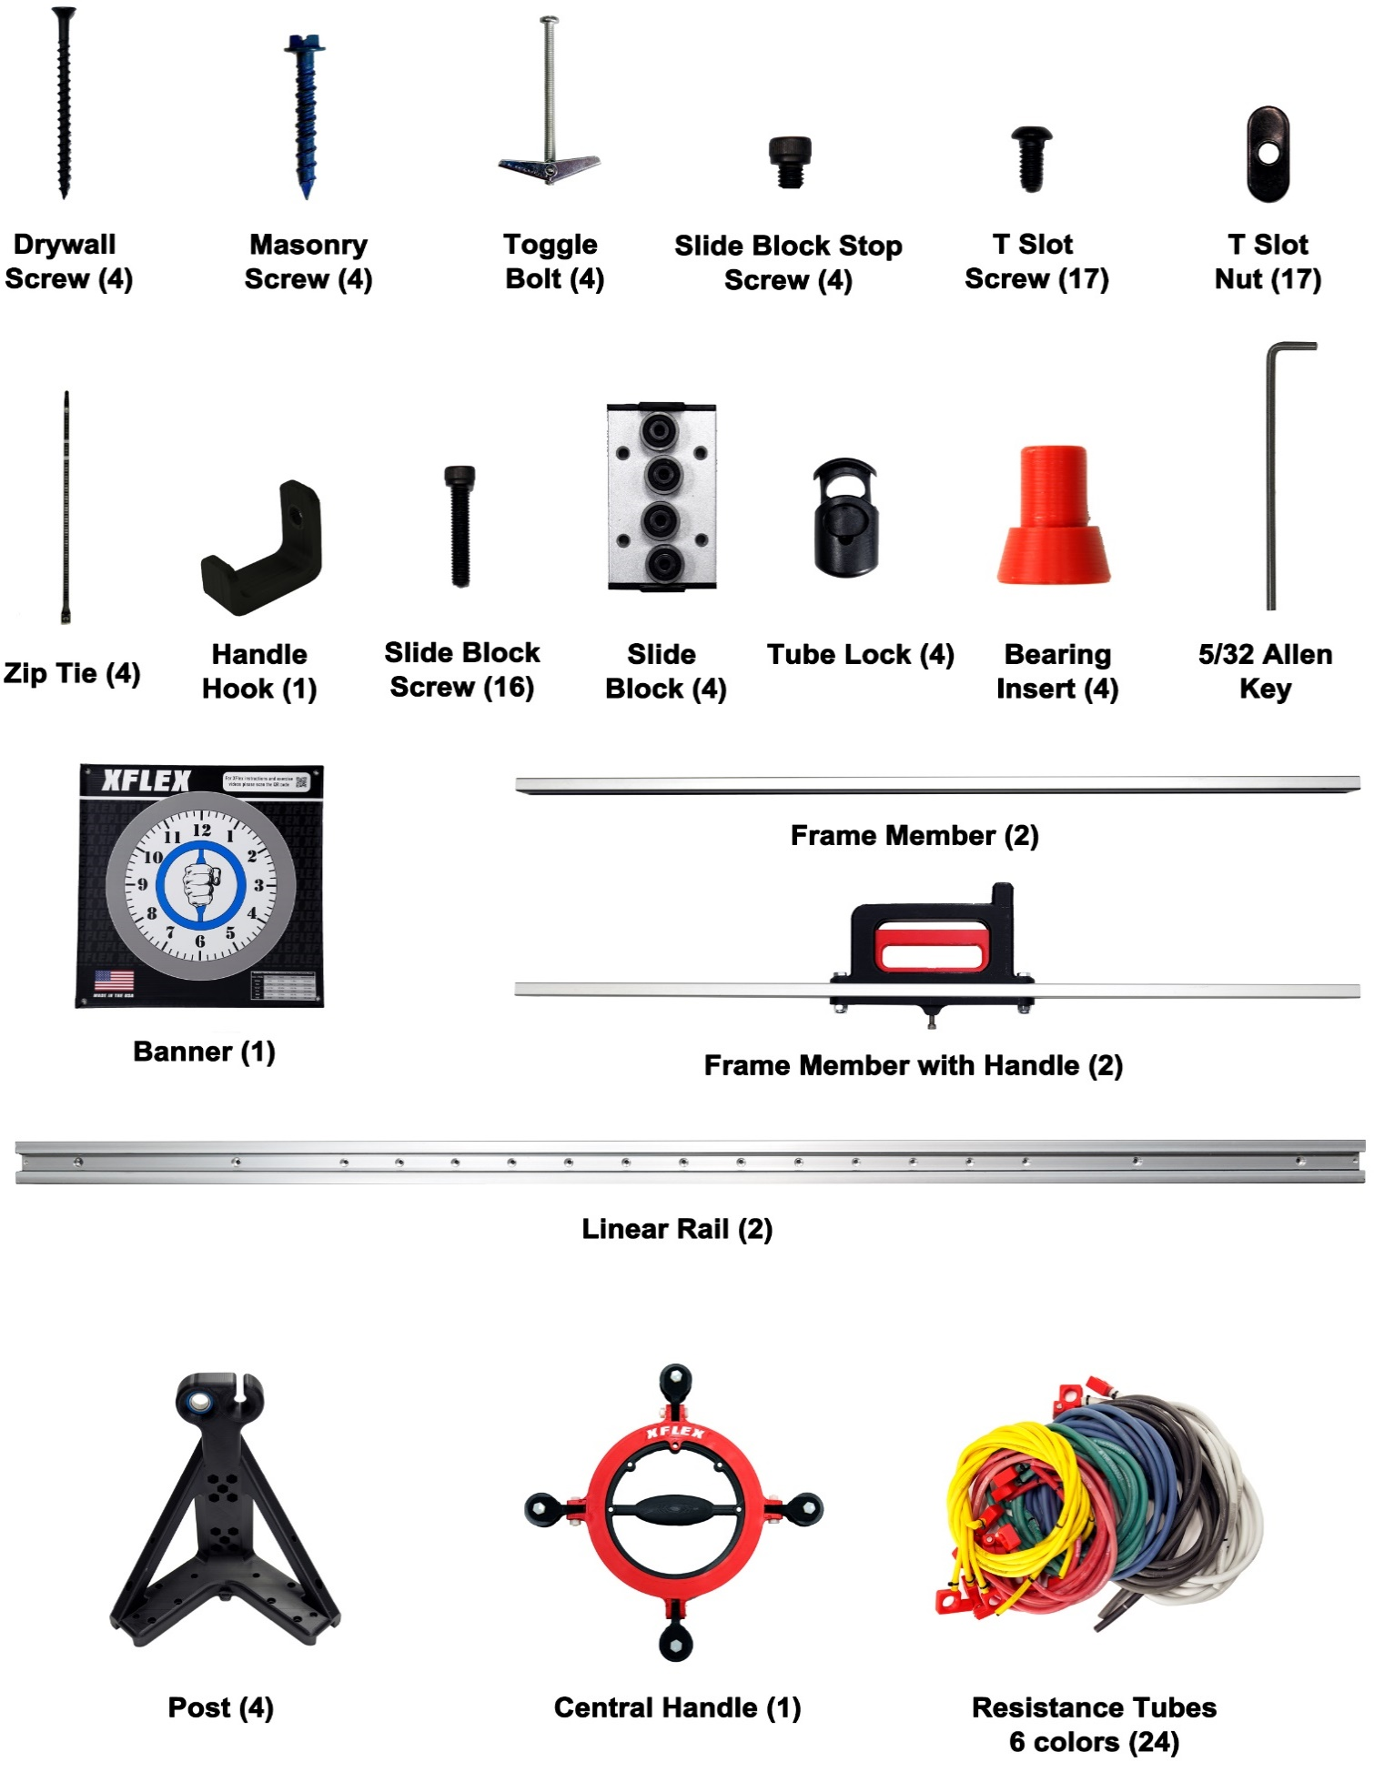

Steps Map
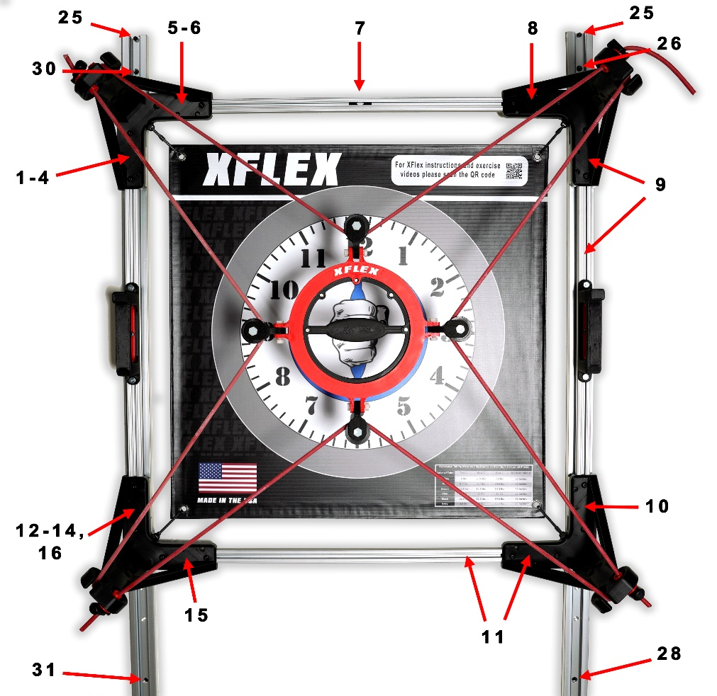

Post Detail
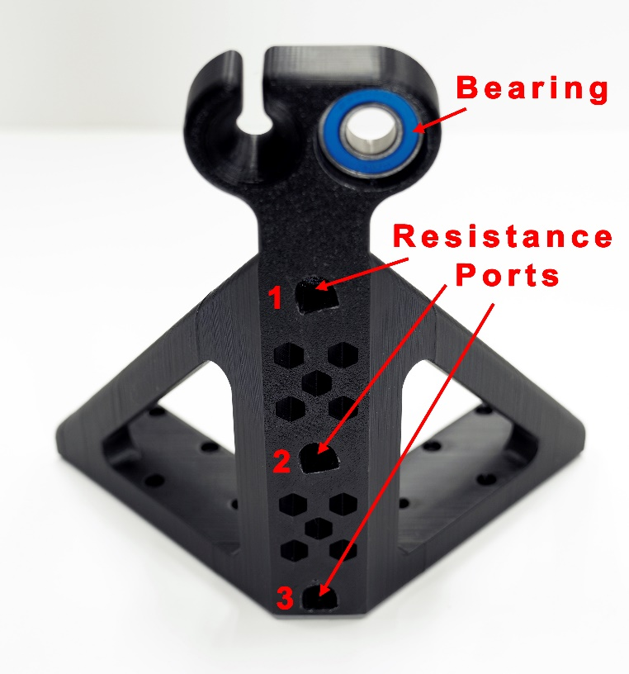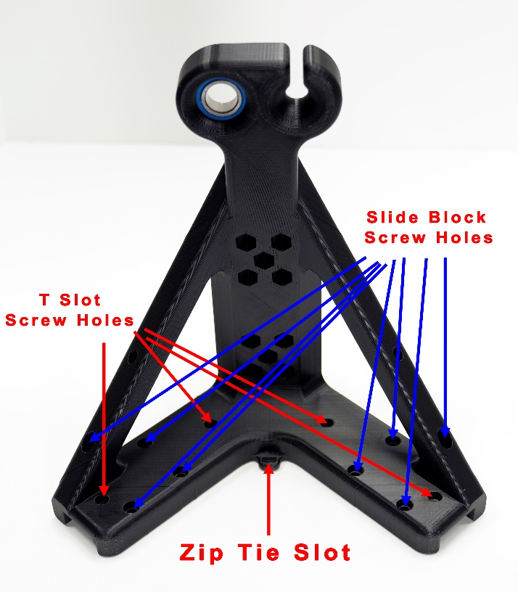
To assemble and install your XFlex, please follow these steps. If you have any questions, please email us at support@h2xflex.com. Thanks!
- To begin, take one post and install (2) T Slot screws into the center holes on its left side. On the underside, attach (2) T Slot nuts, screwing them on just enough to catch the threads. Ensure the T Slot nuts are only partially installed to allow space for sliding them into the frame member in the next step. This post will serve as the top left post.
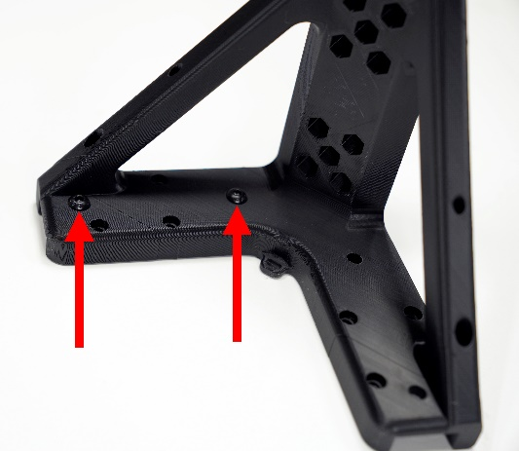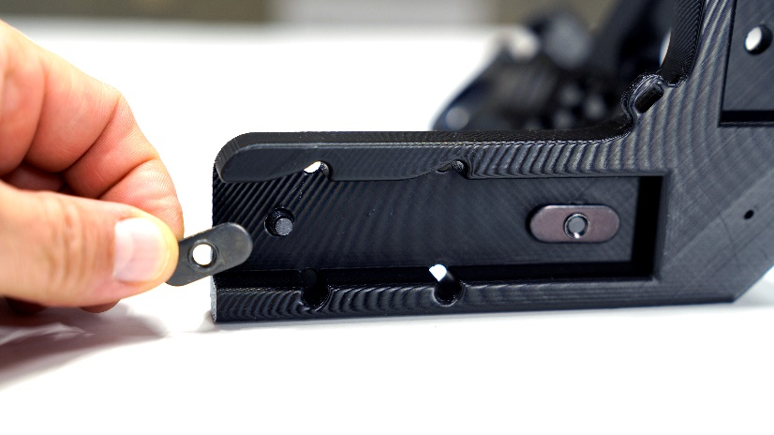
- Insert (1) frame member with the handle into the base of the post.
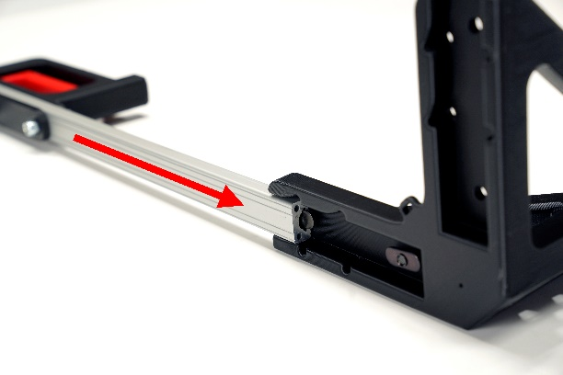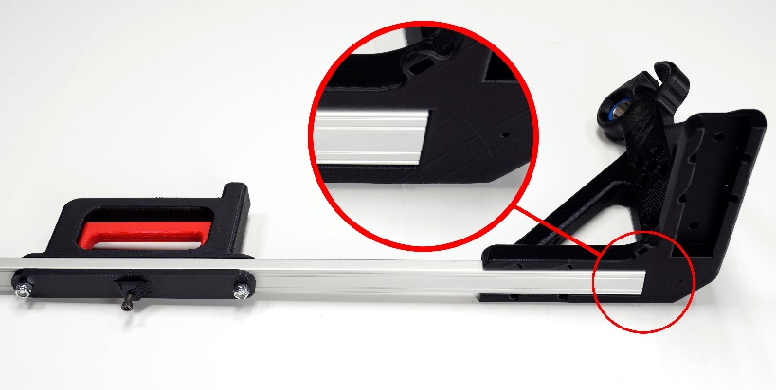
- Ensure the T Slot screws are securely fastened.
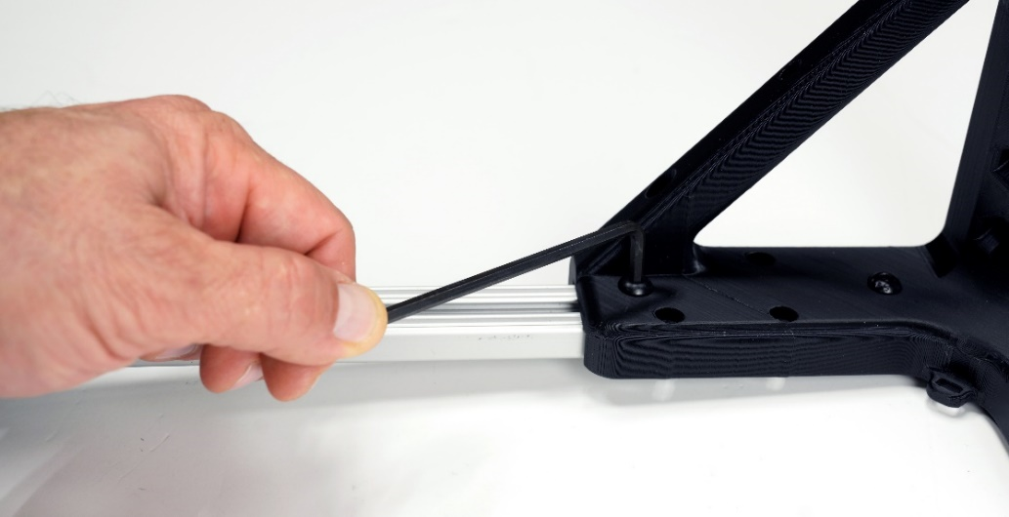
- Position (1) slide block beneath the four remaining holes on the left side of the post. Insert and tighten (4) slide block screws into the holes to secure the slide block to the post.
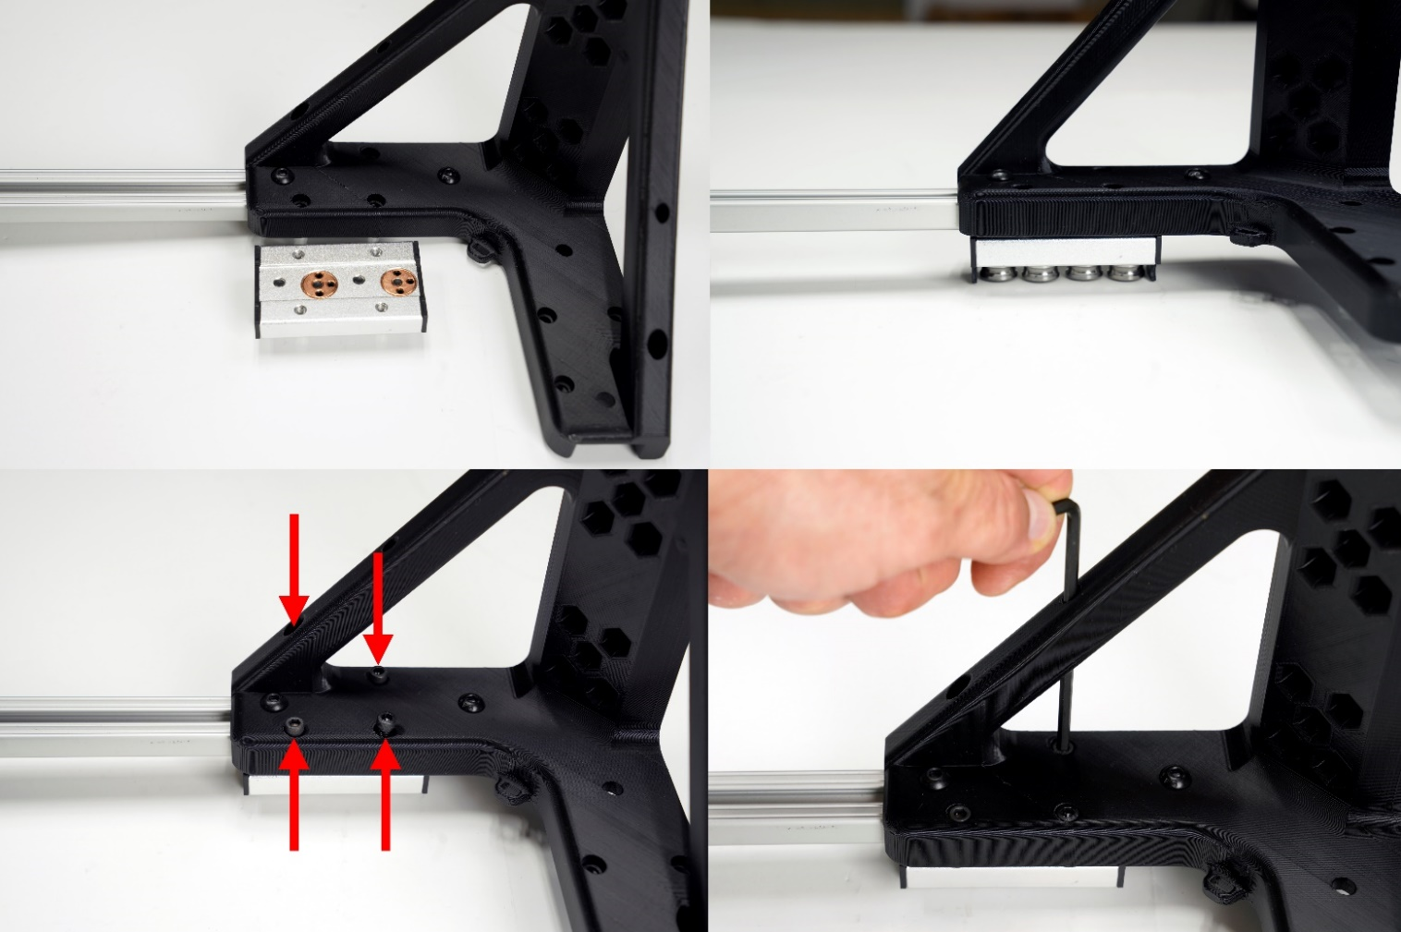
- Install (2) T Slot screws into the two center holes on the right side of the post.
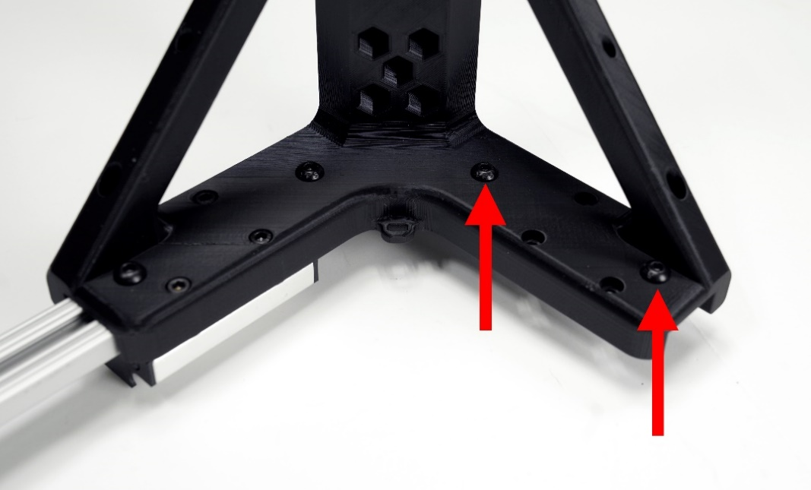
- Similar to step 1, partially install (2) T Slot nuts onto the screws and insert (1) frame member into the post. This will serve as the top frame member. Once the frame member is fully inserted, tighten the (2) T Slot screws.
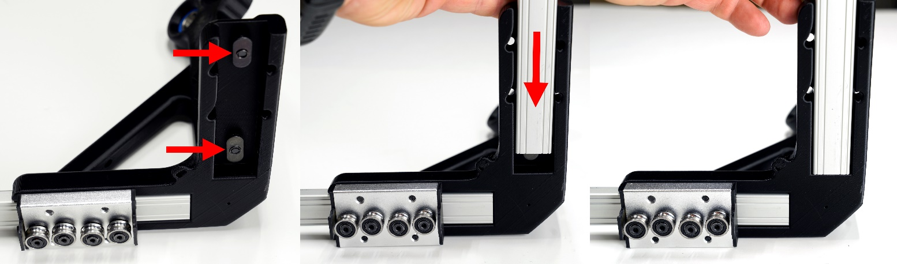
- Insert (1) T Slot nut into the top frame section and position it centrally within the frame member.
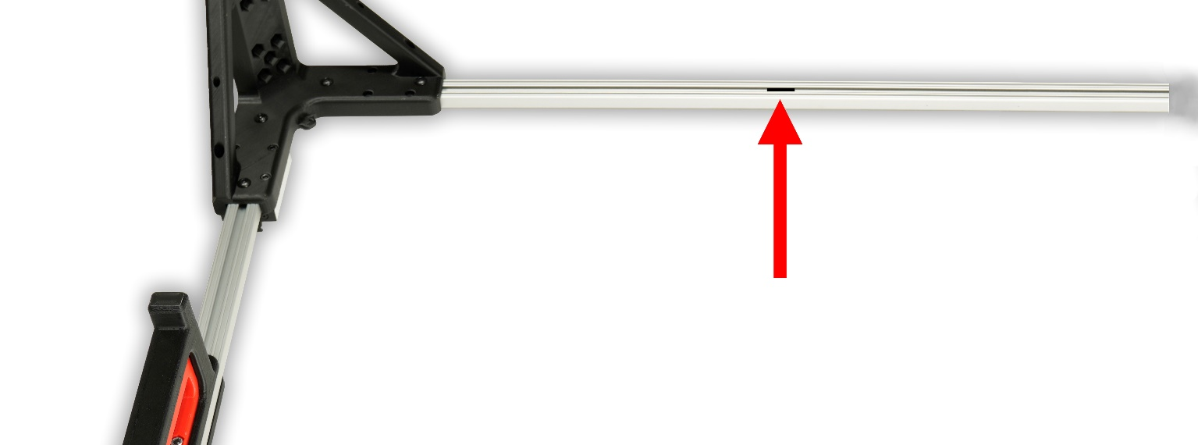
- Use (2) T Slot screws and (2) T Slot nuts to install the top right post onto the top frame member.
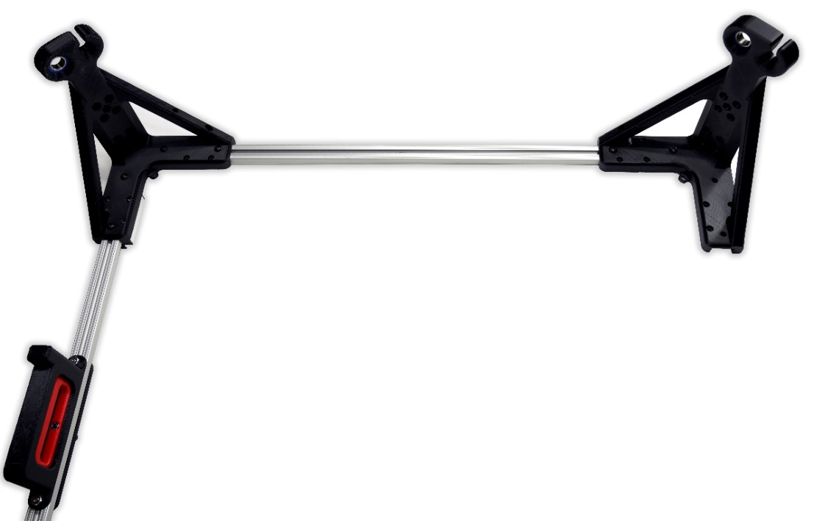
- Use (2) T Slot Screws, (2) T Slot nuts, (1) slide block and (4) slide block screws to install (1) frame member with handle and slide block onto the top right post. Ensure the protruded nub of the handle is on top to match the handle on the left frame member.
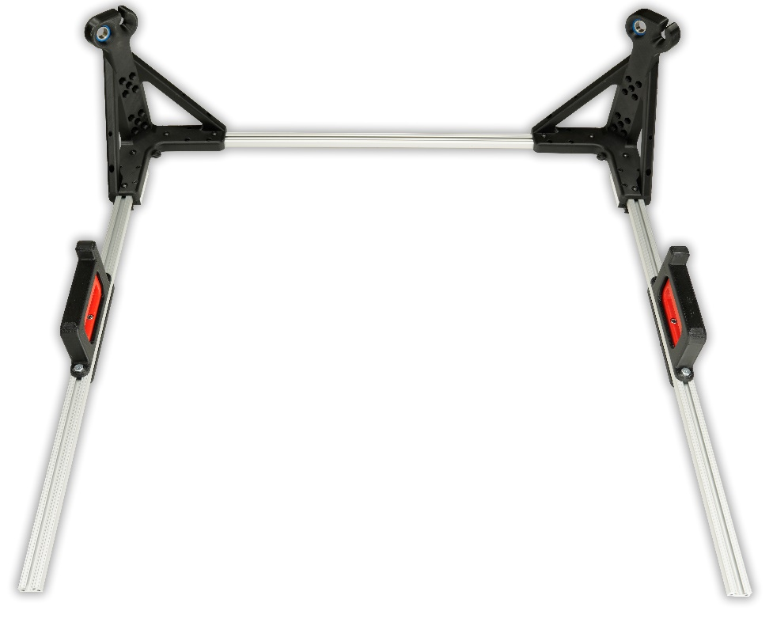
- Use (2) T Slot Screws, (2) T Slot nuts, (1) slide block and (4) slide block screws to install the bottom right post onto the right frame member with handle.
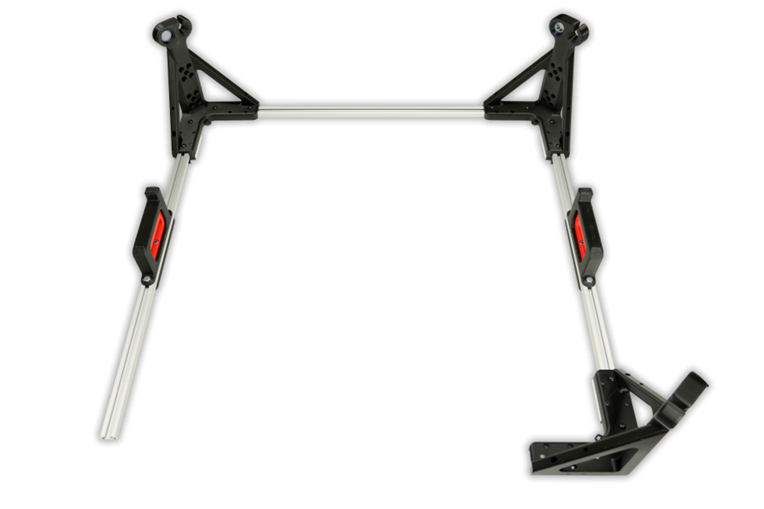
- Use (2) T Slot screws and (2) T Slot nuts to install the bottom frame member into the bottom right post.
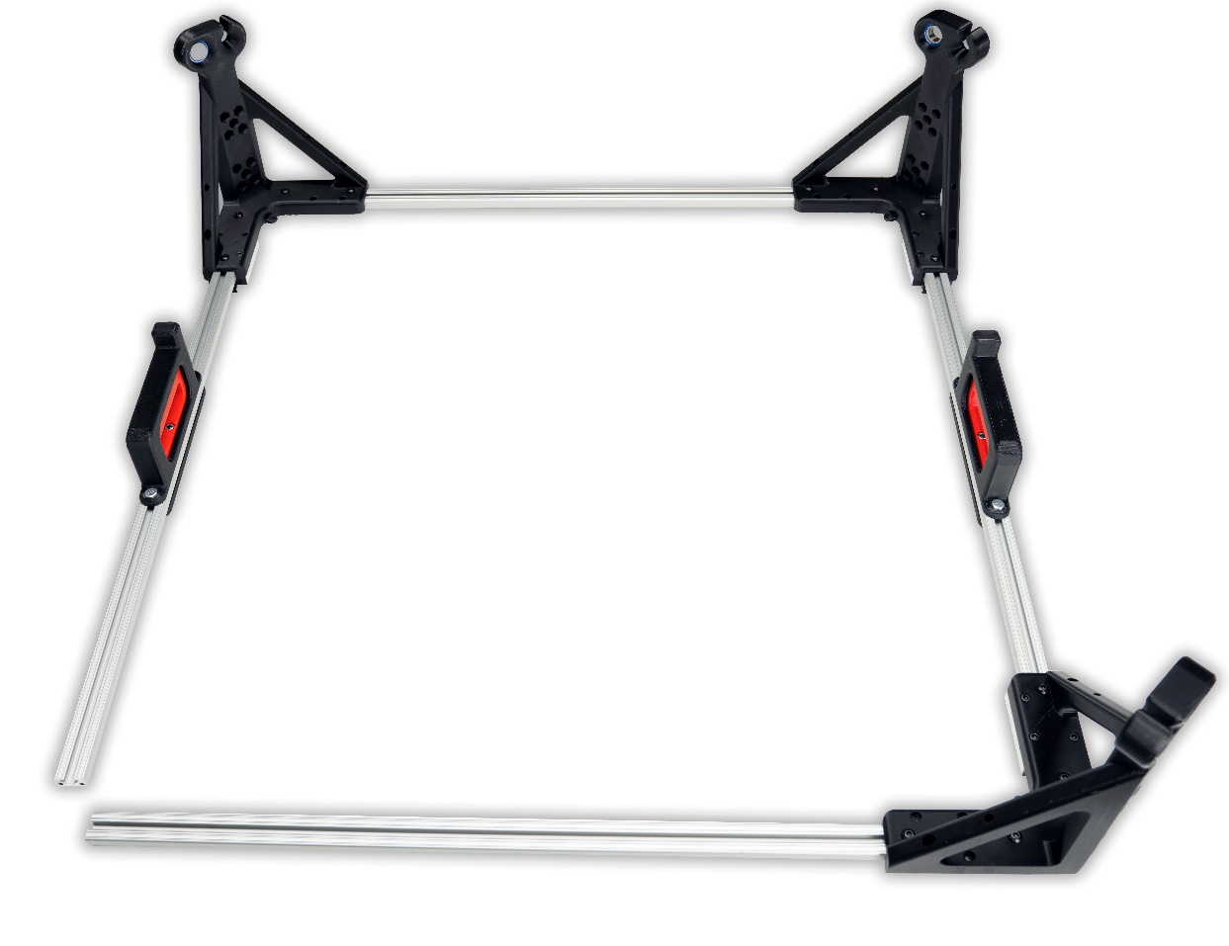
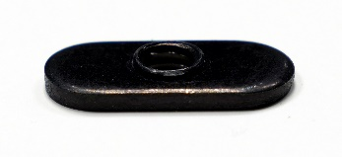
- In this step we are going to preset (2) T Slot nuts into the bottom of the left frame member with handle. Take one of the T Slot nuts and slide it into the left frame member with the raised lip of the tapped hole facing upward.
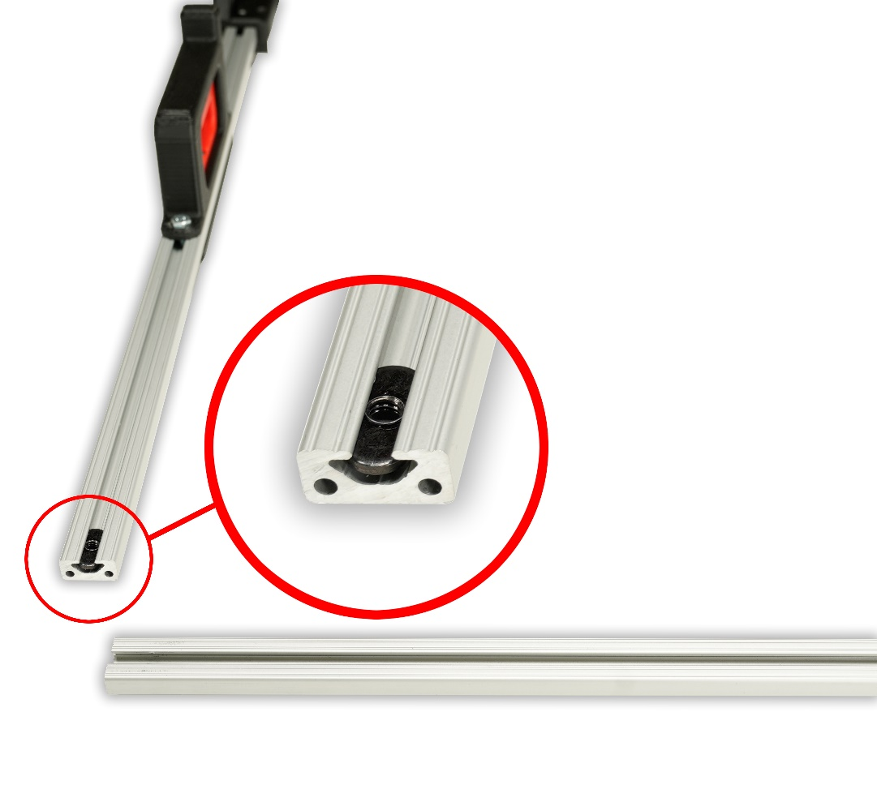
- Take the remaining post and line up the central hole at the end of the right side of the post with the center of the T Slot nut. Take the 5/32 allen key and insert it through the central hole and the T Slot nut. Slide the post up the left frame member until the frame member stops. The T Slot nut is now seated in the proper location.
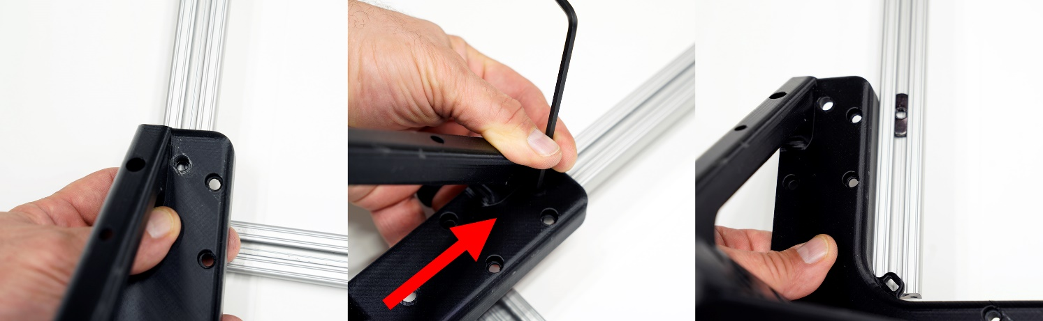
- Repeat the process from the prior step to position the second T Slot nut for the remaining central hole.
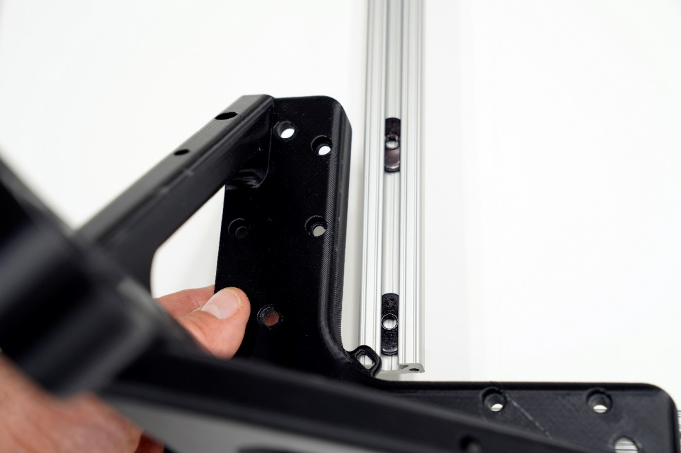
- Use (2) T Slot screws and (2) T Slot nuts to install the right portion of the bottom left post onto the bottom frame member.
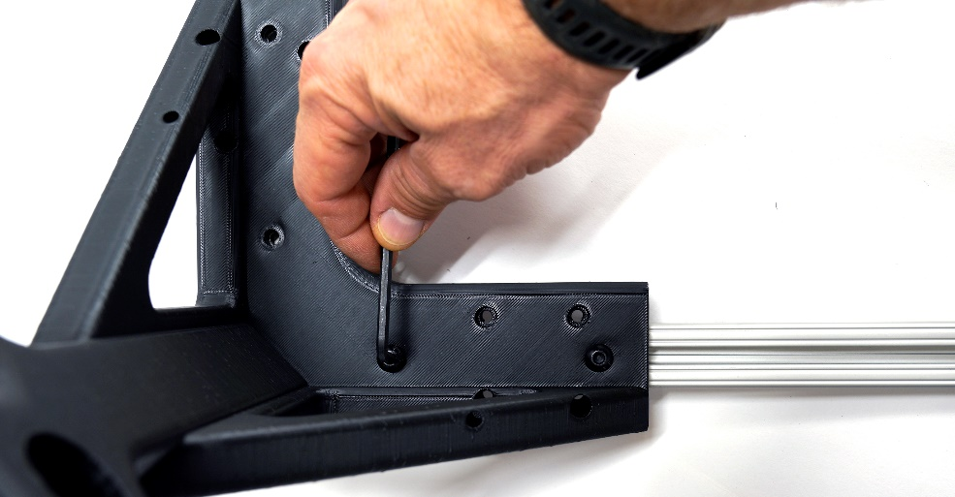
- Position the lower left post onto the left frame member with the handle, and secure it by installing (2) T Slot screws into the T Slot nuts previously installed in steps 13 and 14.
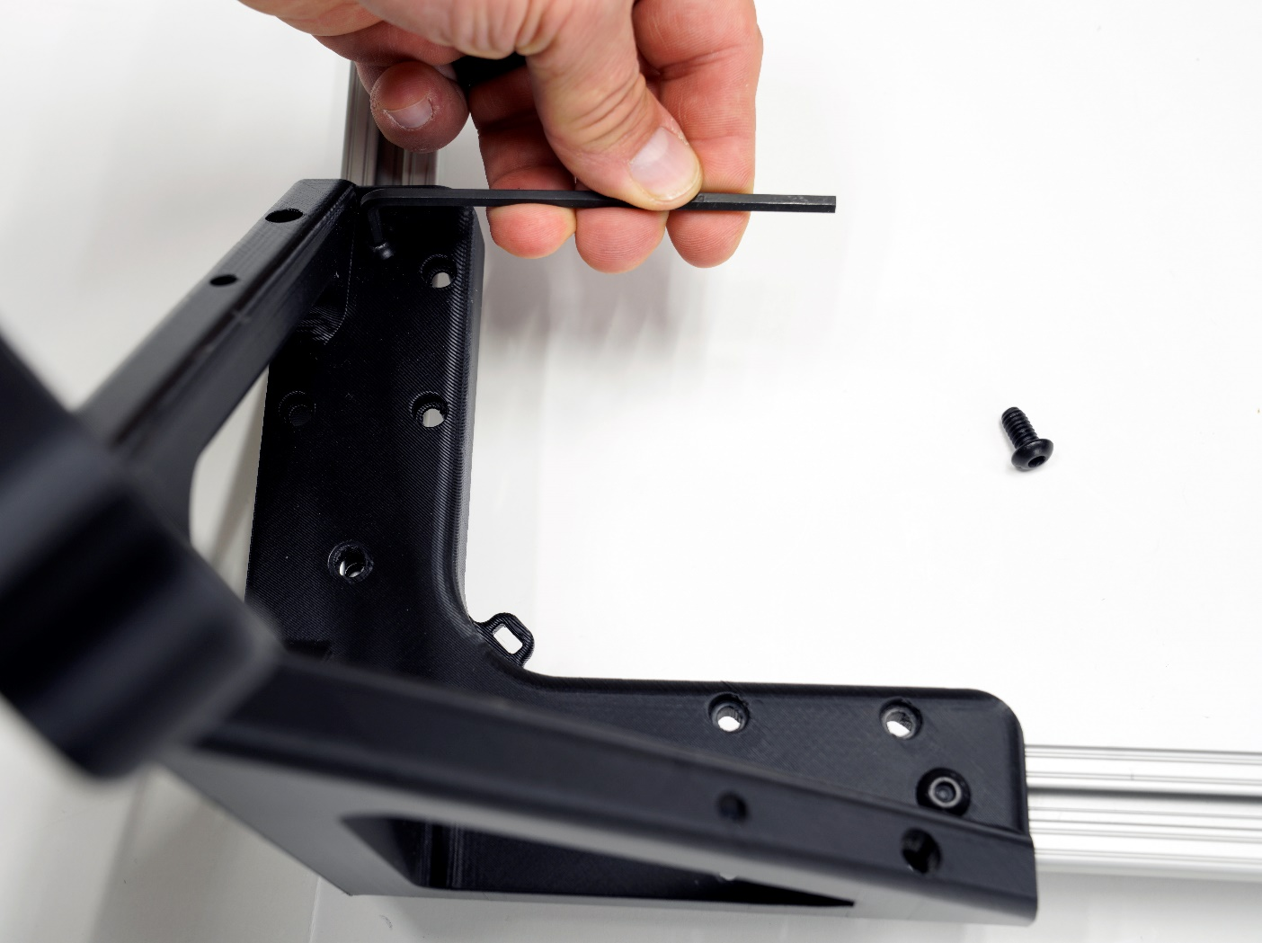
Your frame is now complete!
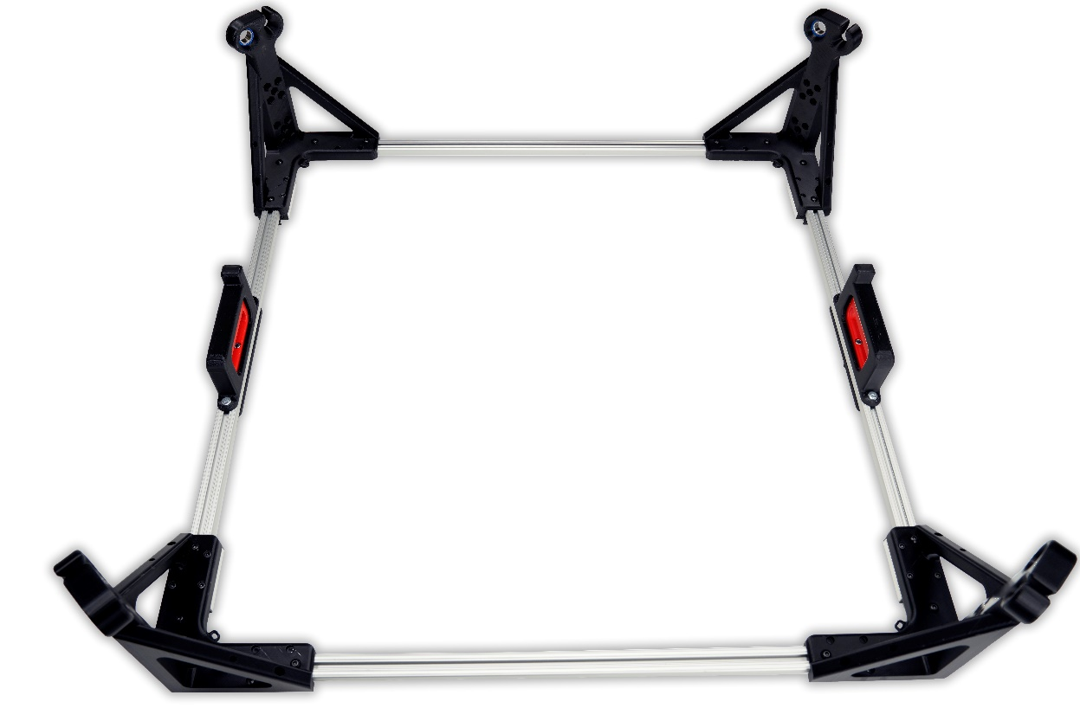
- Arrange the banner in the following orientation for installation.
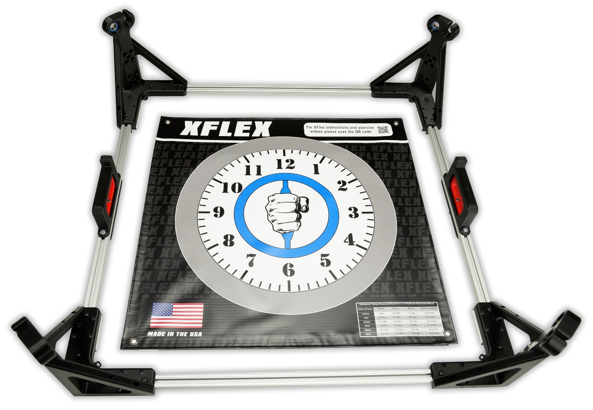
- Flip the frame and the banner upside down while maintaining this orientation.
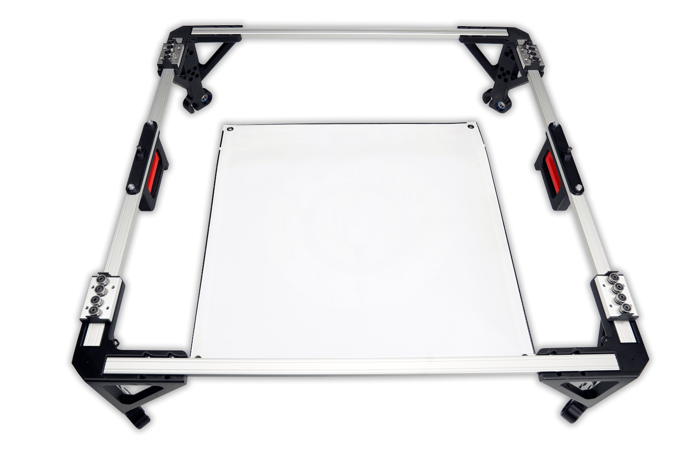
- Insert (1) zip tie into the bottom right post tie rap hole and fasten it to the banner. Take the zip tie to the first silver mark.
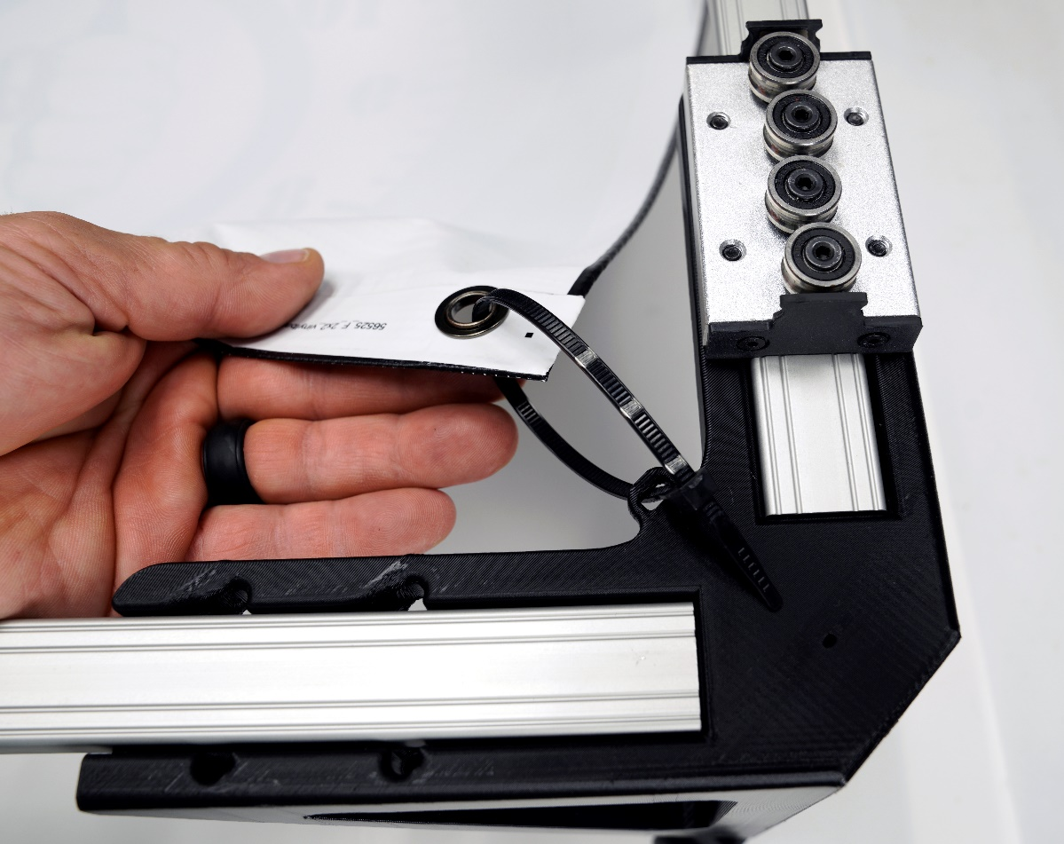
- Fasten the (3) remaining tie wraps to the unfastened corners. Use the silver marks on the zip ties to gradually tighten each one equally until the banner is taut. Trim the excess zip tie material.
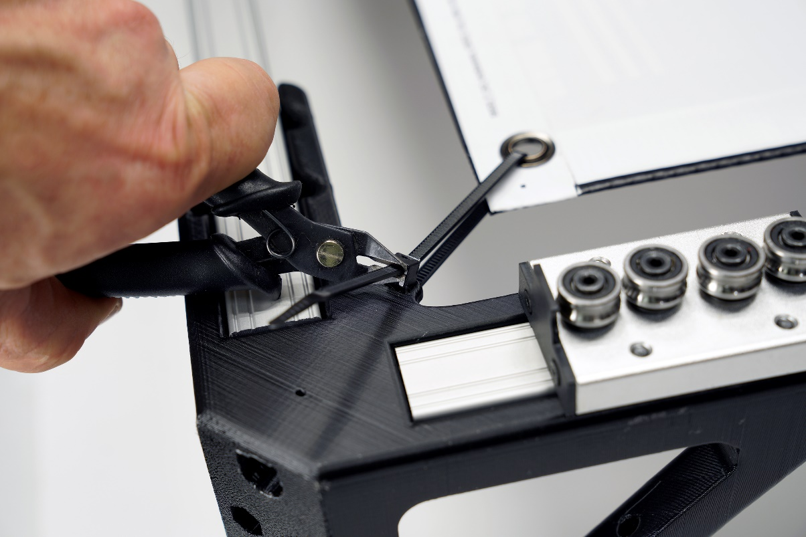
Congrats! Your banner is installed.
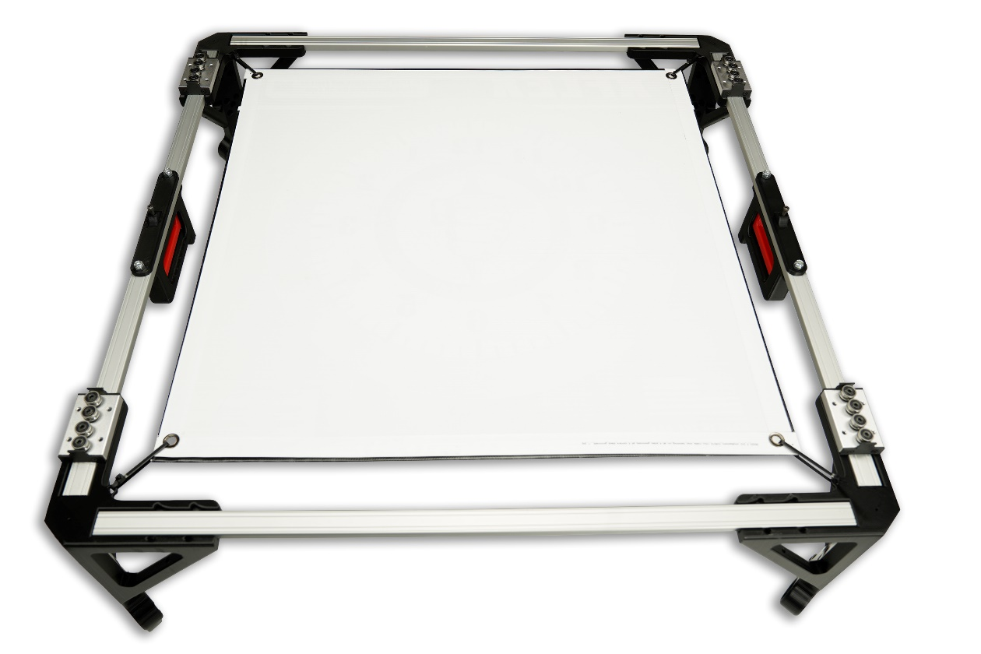
- While keeping the XFlex frame upside down, we will now insert the linear rails. Take (1) linear rail and push it through the wheels of one of the slide blocks.
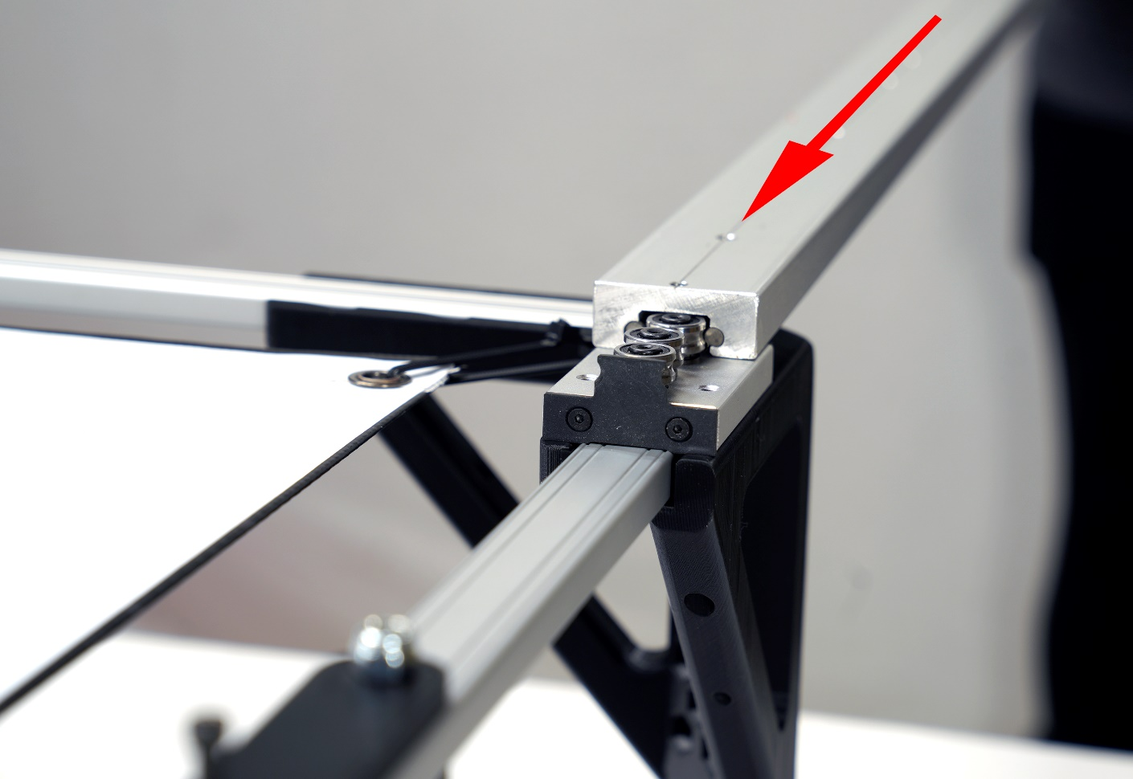
- Continue pushing the linear rail until it passes through the wheels of the second slide block. You may have to squeeze the handle on the frame member to allow the linear rail to pass through.
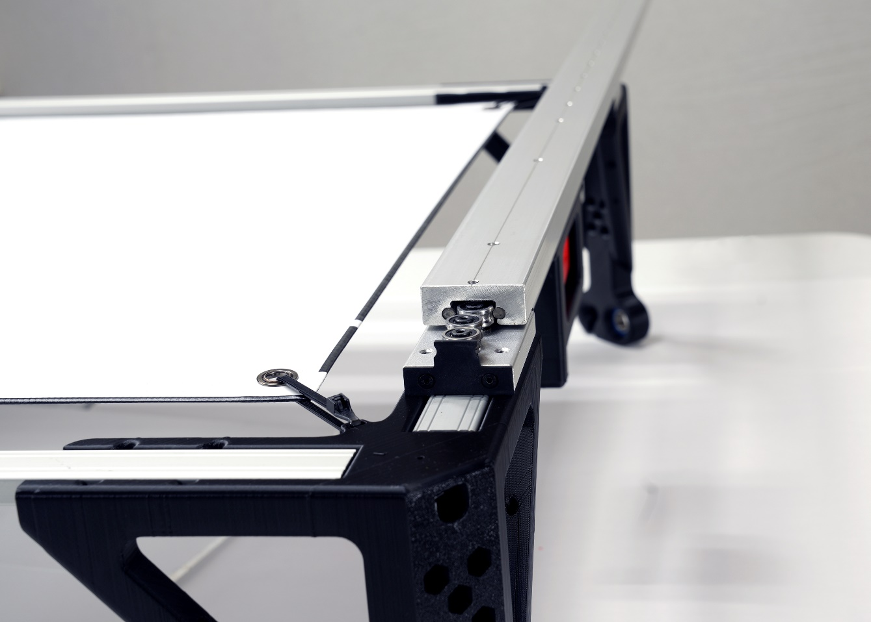
- Once the linear rail is pushed through both slide blocks, squeeze the frame member handle and adjust the linear rail until the handle securely locks into the central adjustment hole.
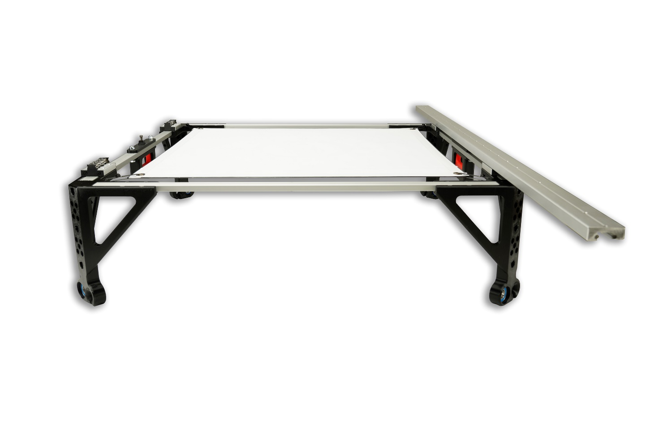
- Repeat the process to install and center the remaining linear rail onto the XFlex frame.
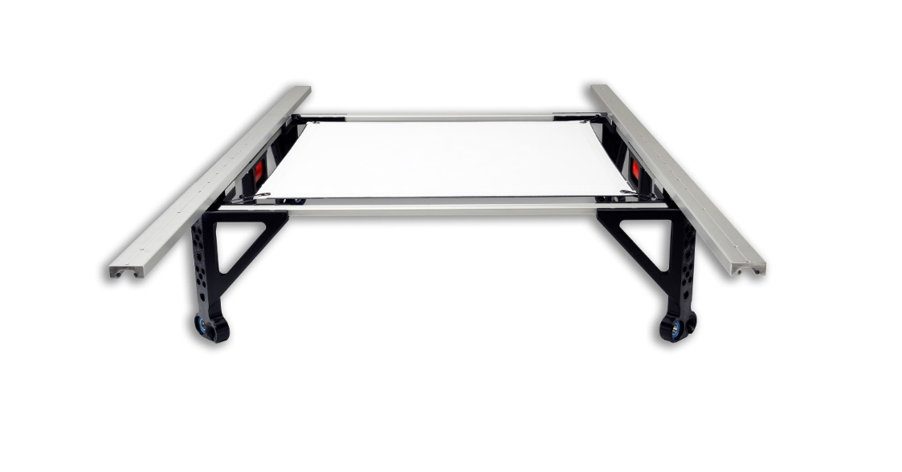
- Install (4) slide block stop screws into the ends of the linear rails.
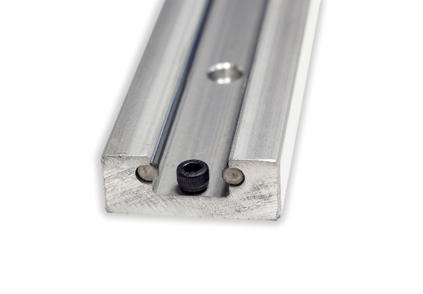
Congrats! Now the base frame of the XFlex is assembled.
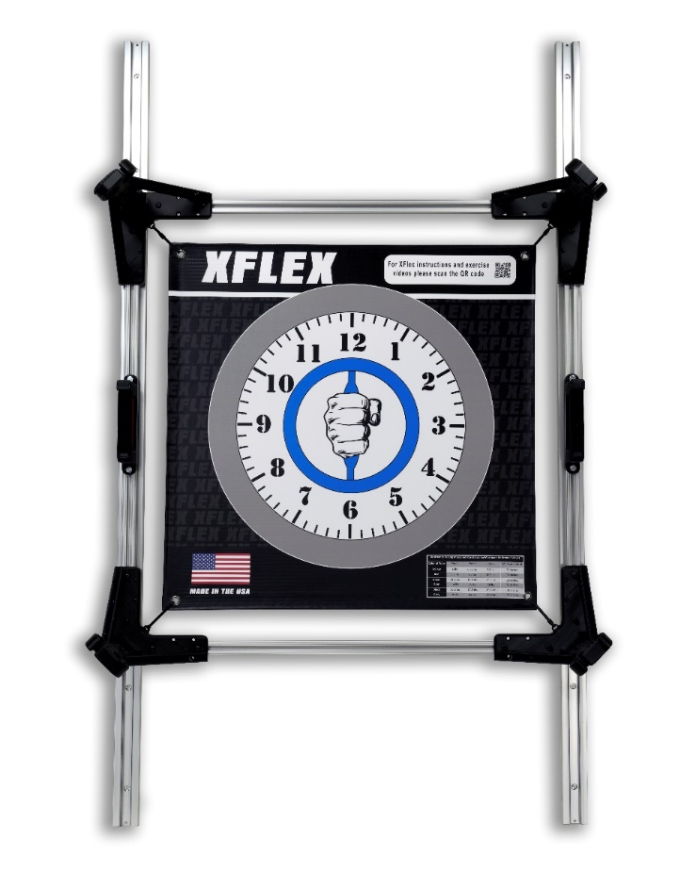
Installing the XFlex to a wall
The XFlex includes hardware for versatile wall installation. For concrete block, brick, or concrete walls, use the masonry screws. For walls with 16-inch center studs, use drywall screws. For hollow walls without 16-inch center studs, toggle bolts are suitable. The linear rail's mounting holes are positioned as the second and third holes from each end, spaced 32 inches apart. In this scenario, the XFlex is being mounted on a drywall wall with 16-inch center studs.
- Mark the center of the wall studs where you are going to mount the linear rails of the XFlex. Screw (1) drywall screw into one of the two top right mounting holes. It does not matter which of the mounting holes you use.
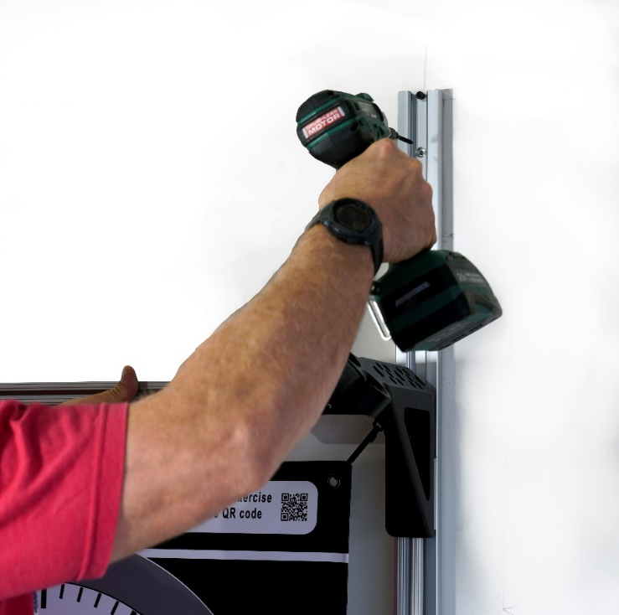
- With a level, plumb up the right linear rail.
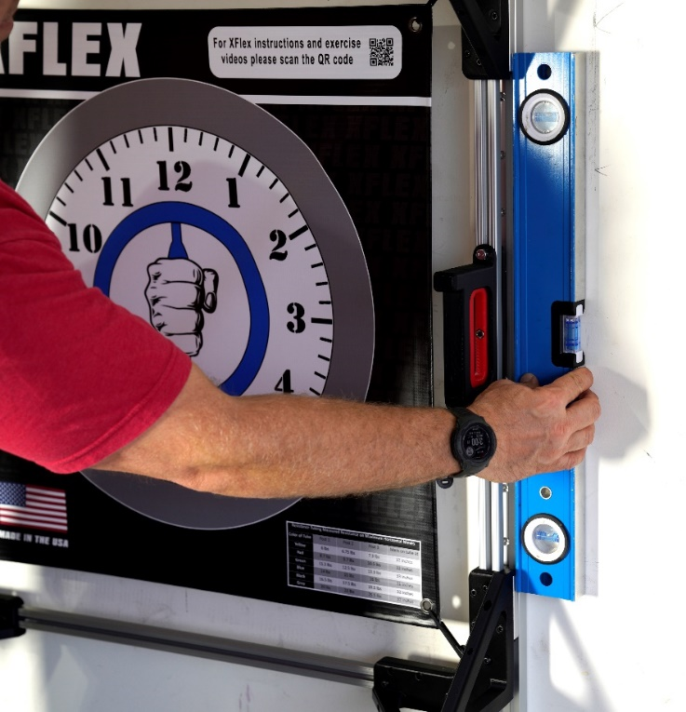
- Install the (1) drywall screw into one of the right linear rail’s bottom mounting holes.
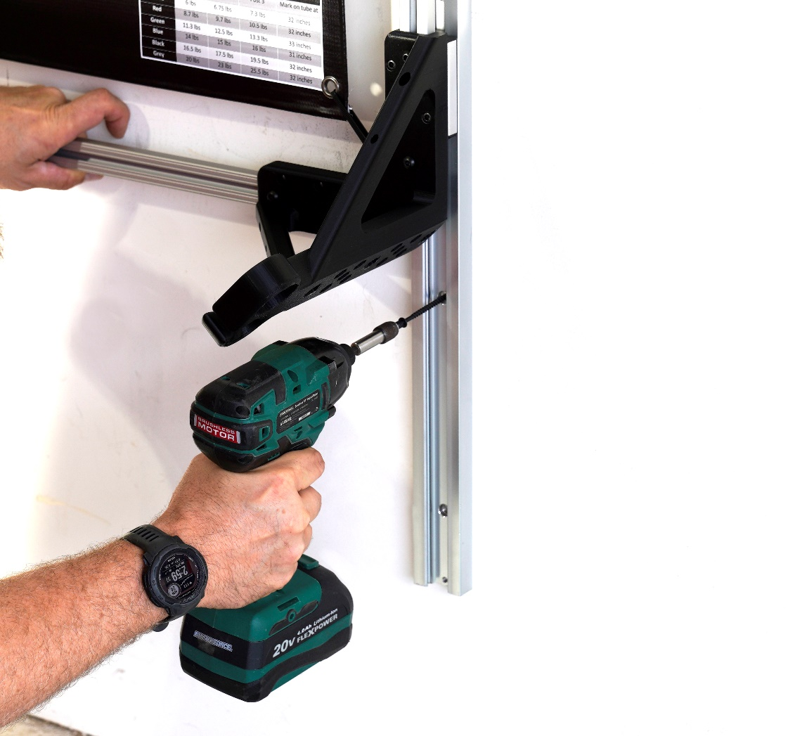
- Use a level to ensure the top frame member of the XFlex is level.
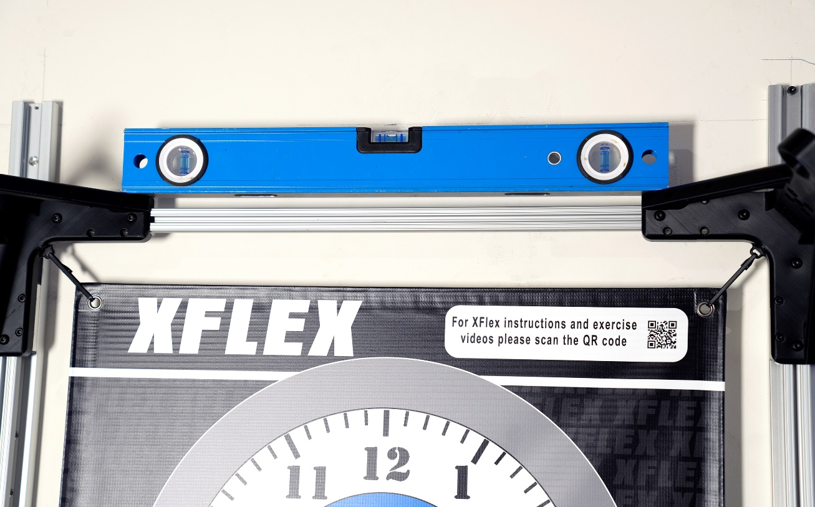
- Install (1) drywall screw into one of the left linear rails top mounting holes.
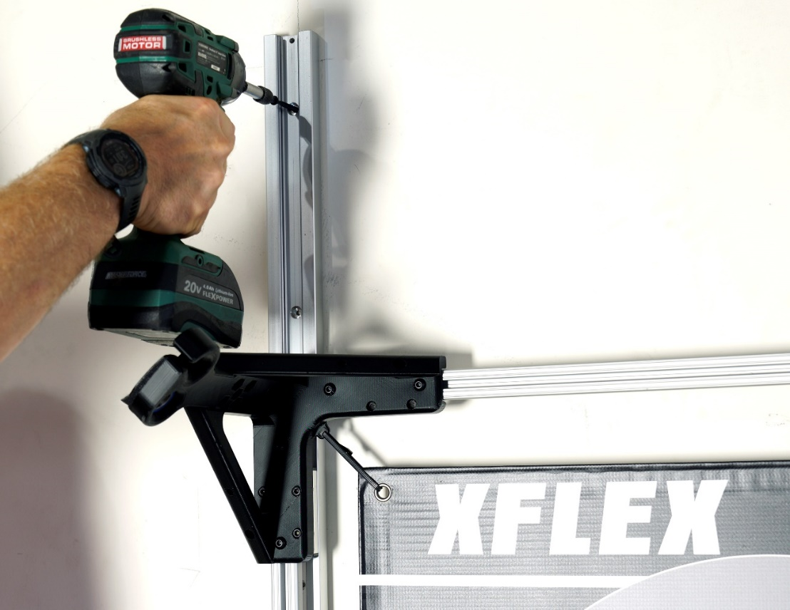
- Install (1) drywall screw into one of the linear rail’s bottom mounting holes.
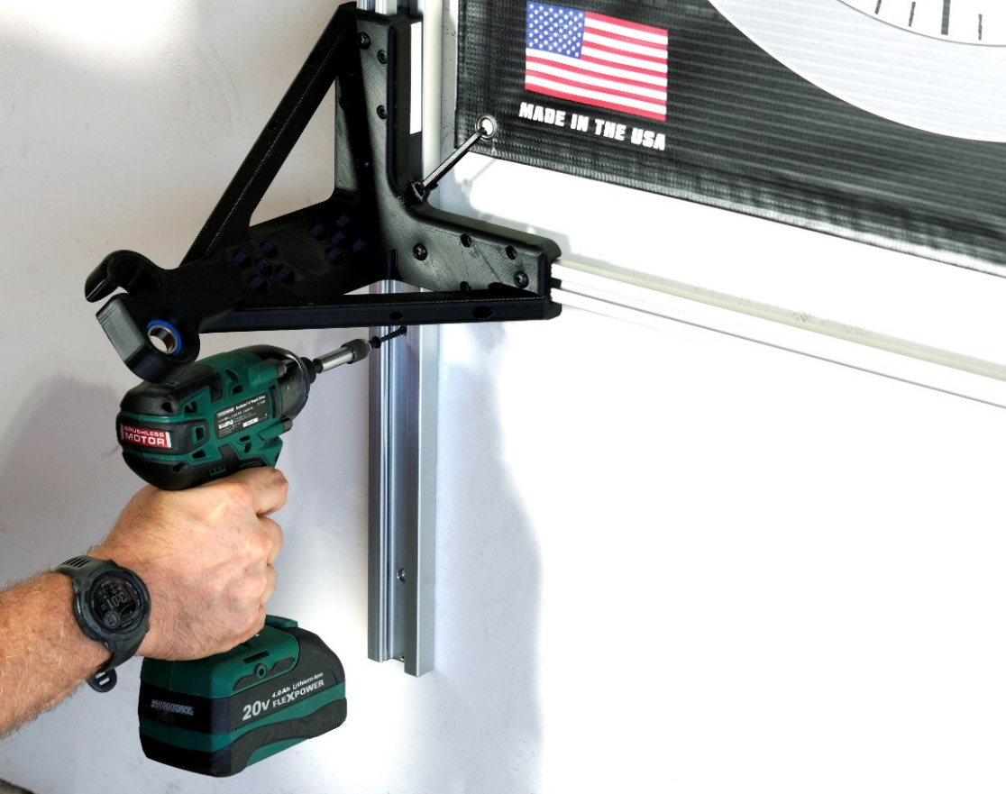
- The XFlex should now be mounted to the wall. Ensure you have fluid adjustments and that the locking handles both lock into adjustment holes at the same time. To move the frame vertically on the linear rails, squeeze the locking handles to raise or lower the XFlex.
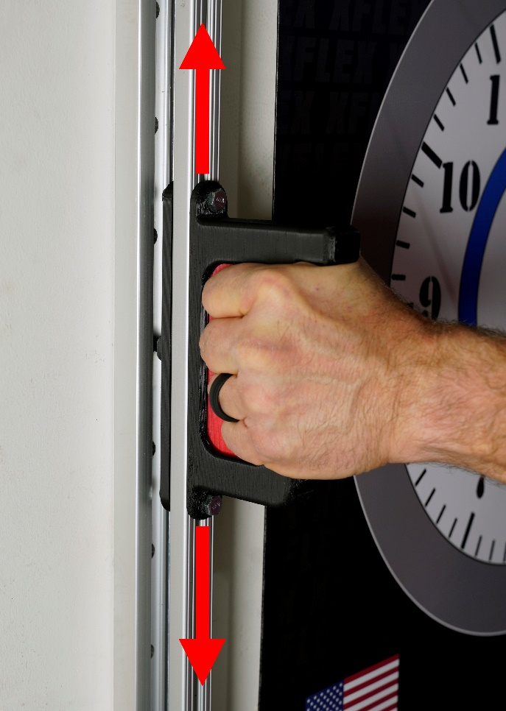
- Use (1) handle hook and (1) T Slot screw to install the handle hook to the T Slot nut that was positioned in step 7.
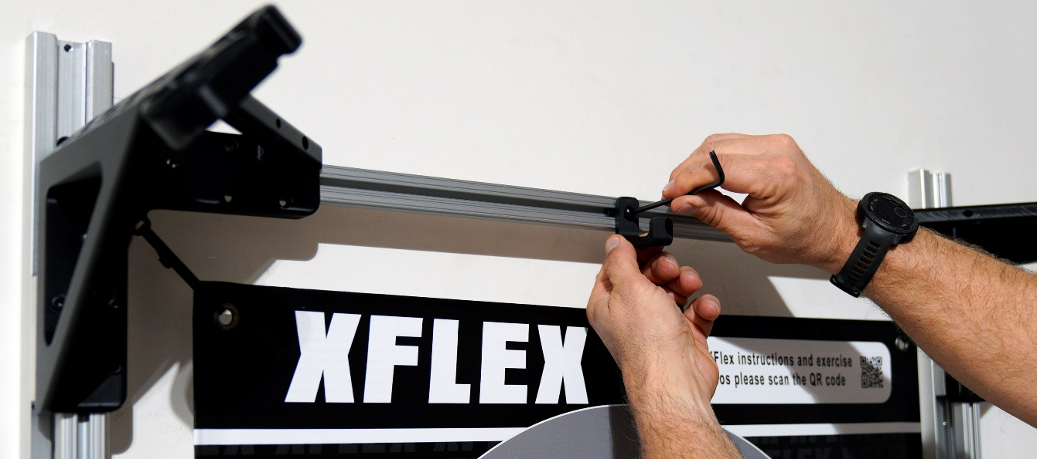
- Take (1) resistance band and insert its magnetic plug into one of the 3 resistance ports on the upper left post.
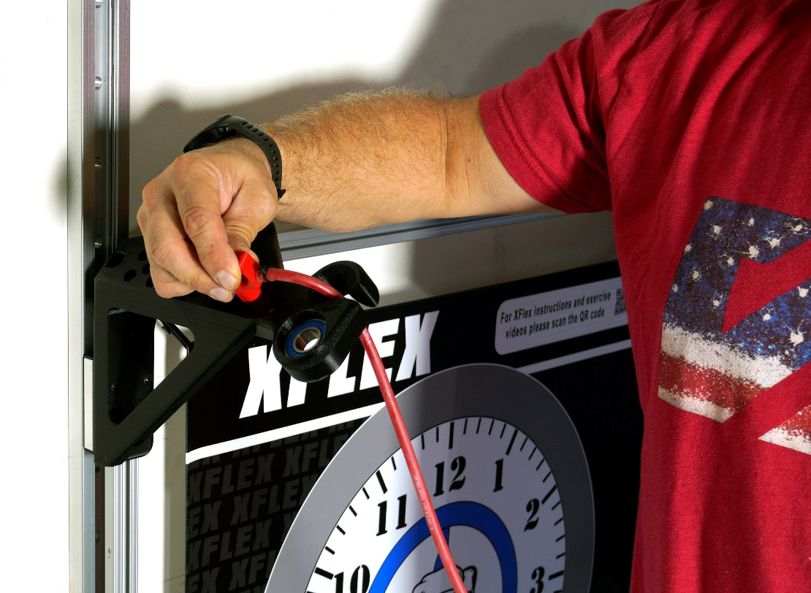
- Route the end of the resistance tube through the upper wheel of the central handle.
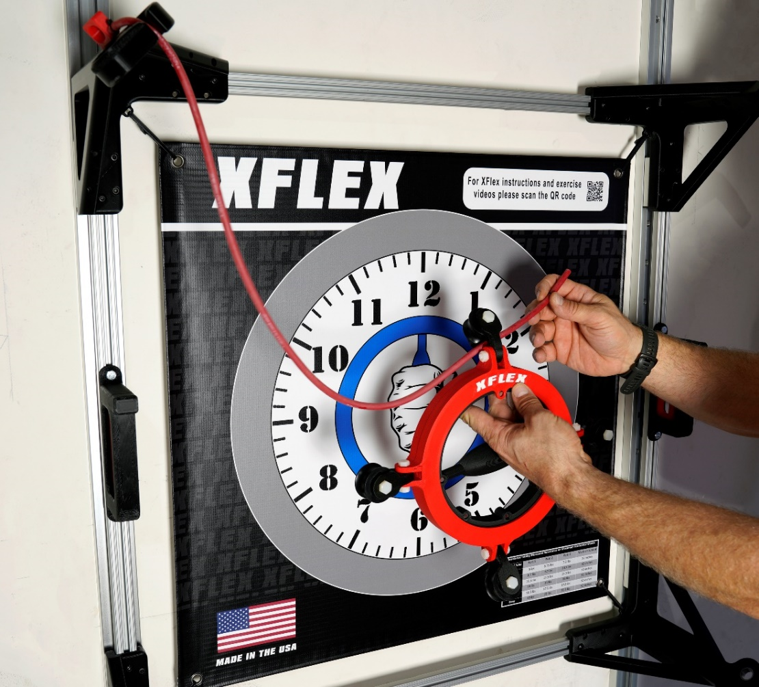
- Install (1) bearing insert into the upper right post’s bearing.
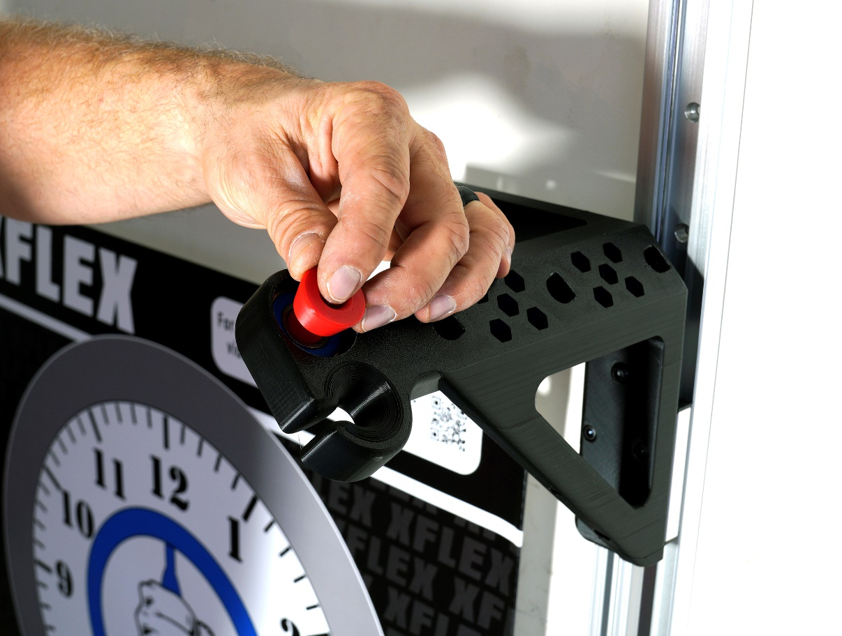
- Thread the end of the resistance tube through the bearing and install (1) tube lock at the black mark on the band.
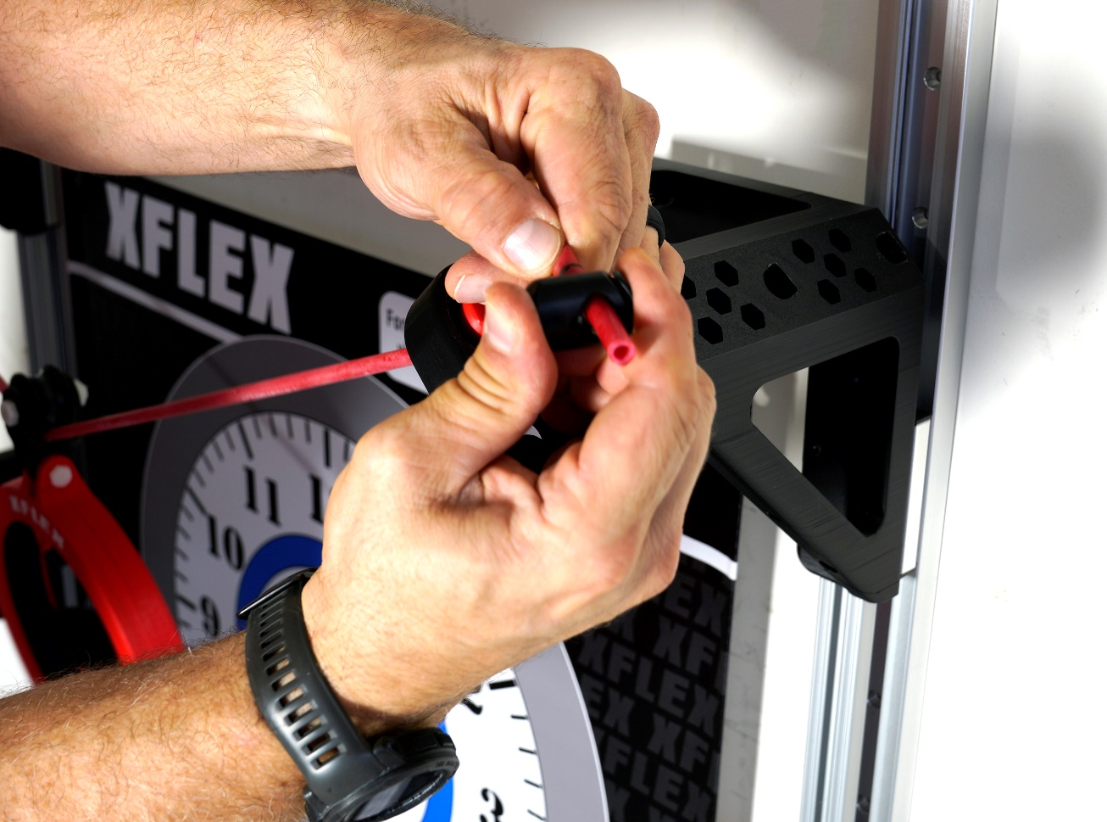
Your XFlex should now look like this.
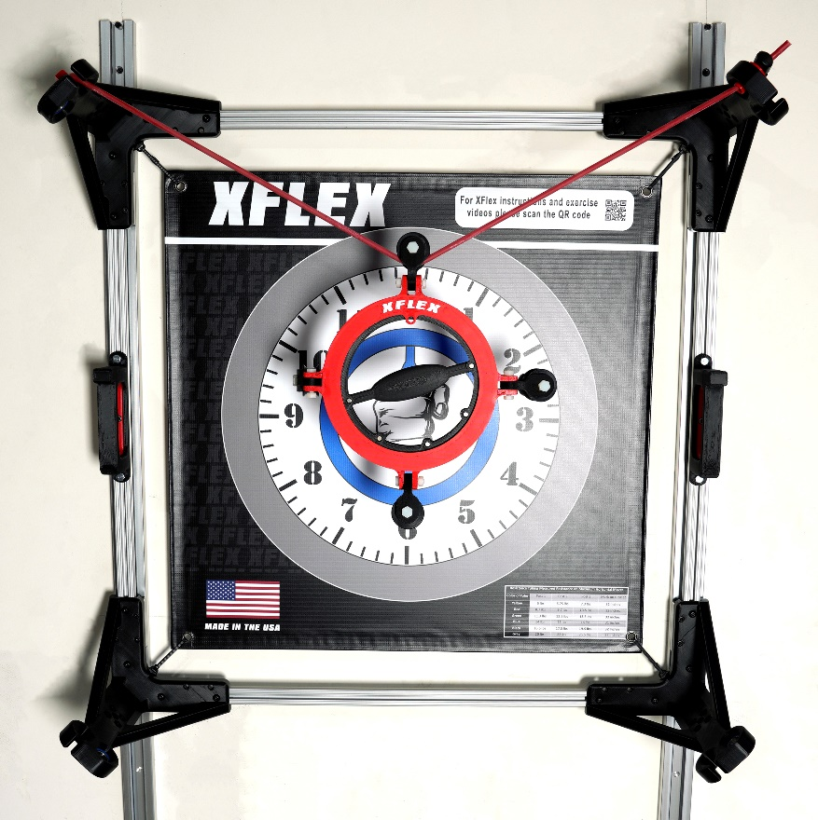
- Using the same process, install (1) resistance band from the upper right post to the lower right post.
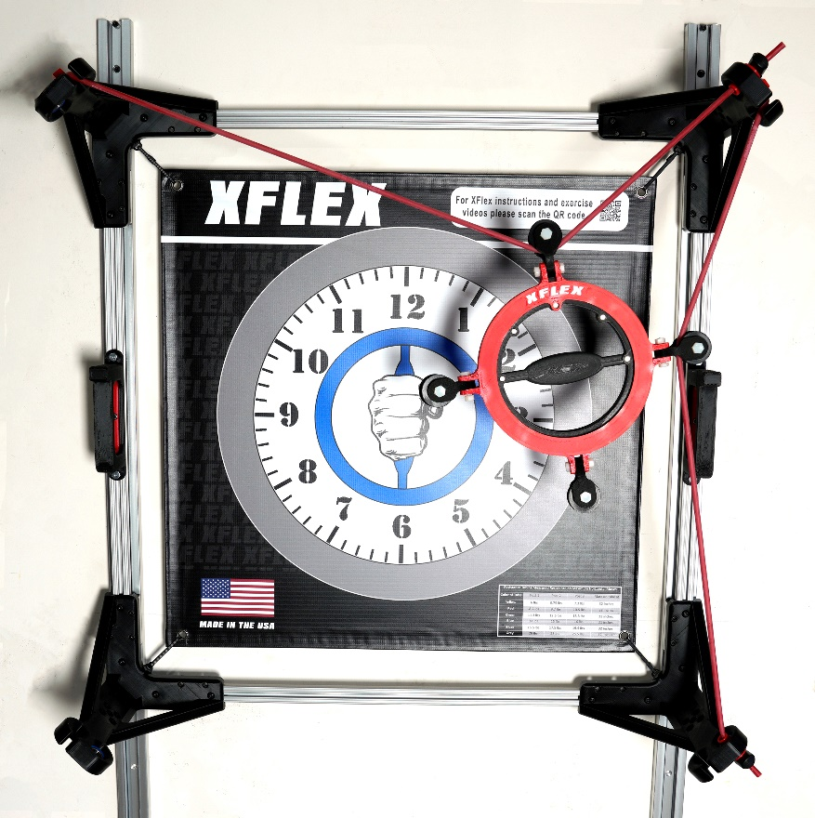
- Install (1) resistance band from the lower right post to the lower left post.
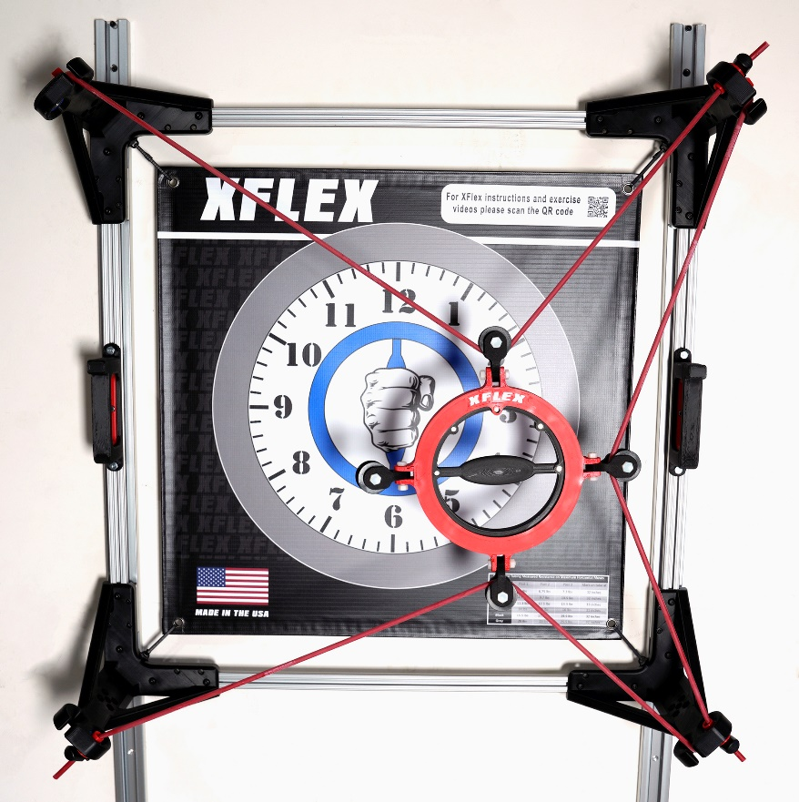
- Install (1) resistance band from the lower left post to the upper left post. You have now successfully installed all four resistance tubes.
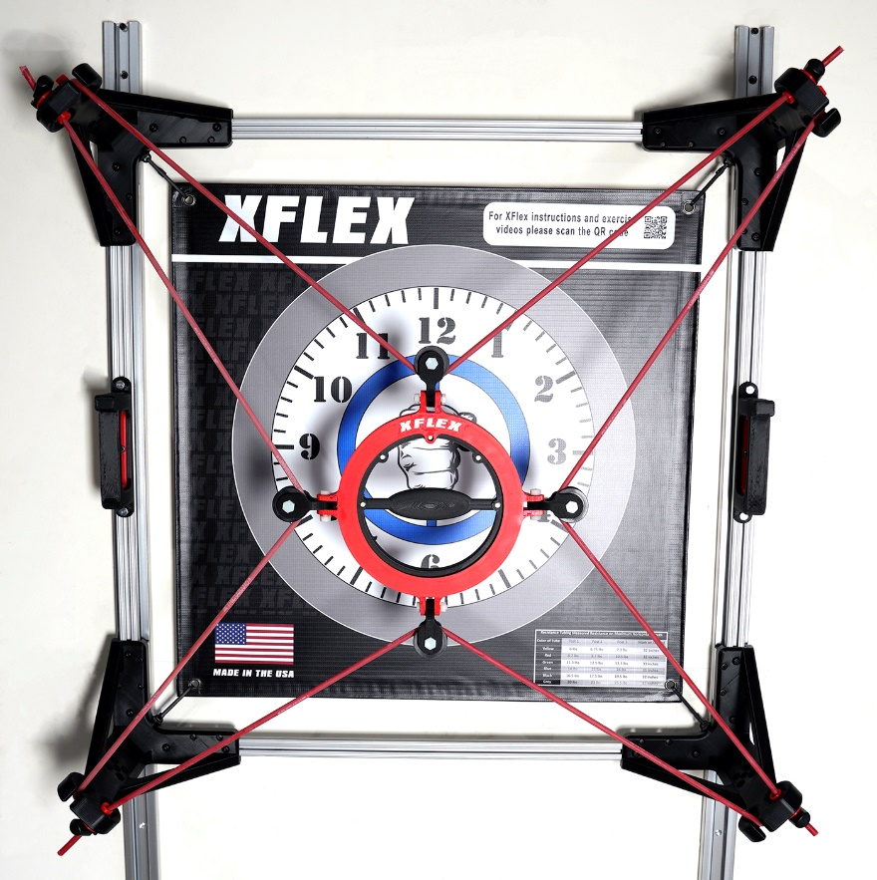
- To offset the sag caused by the weight of the central handle, adjust the top resistance band until the central handle is centered over the handle on the banner.
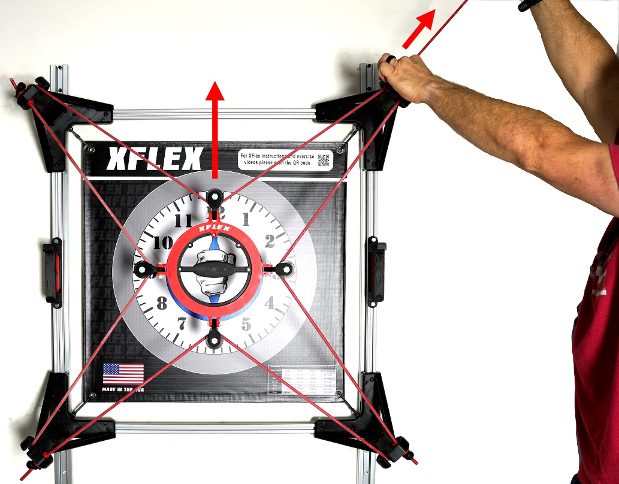
The installation of your XFlex is now complete! Congrats!
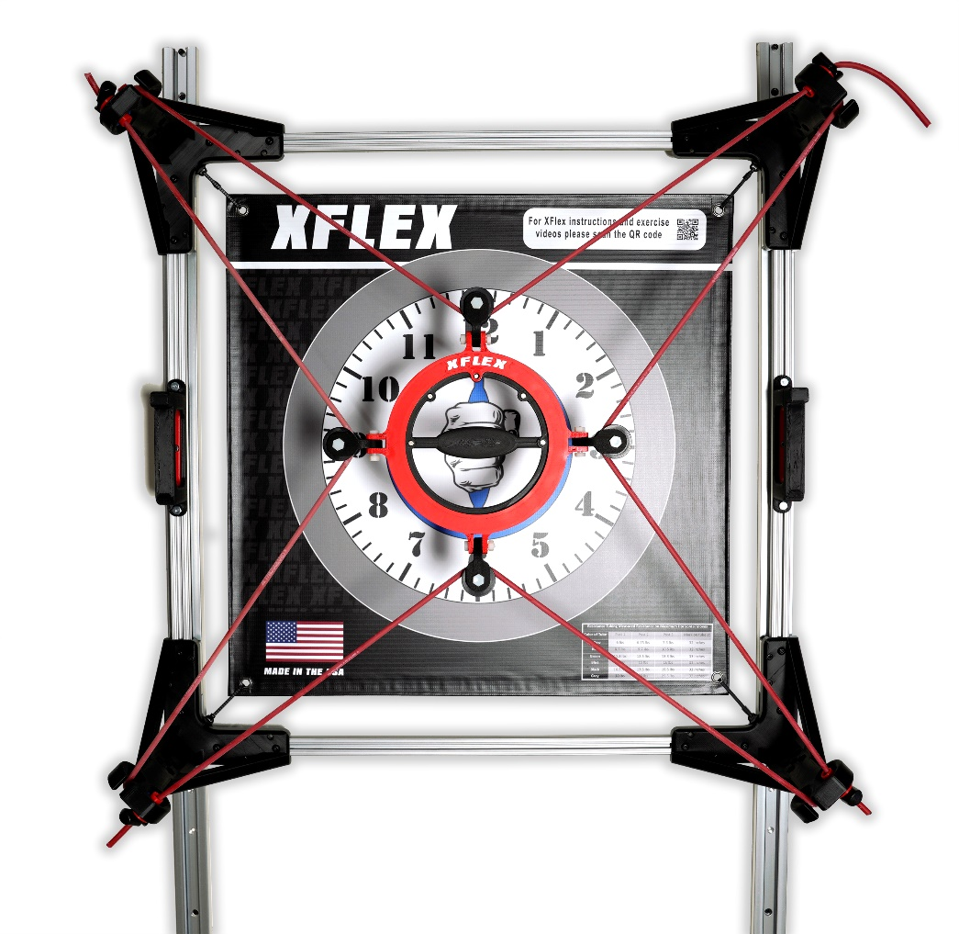

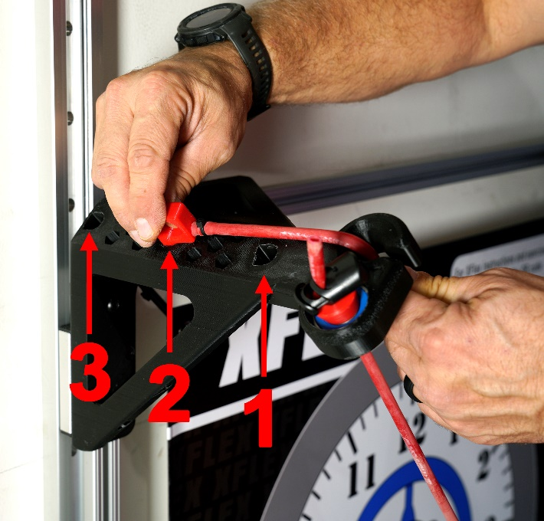
Using the XFlex

The XFlex provides omnidirectional resistance to the movement of the central handle. There are many exercises available on our website that can strengthen various parts of the upper body and torso.
The resistance level of the XFlex can be adjusted to suit each individual user’s needs. Simply change out the colored resistance bands to increase or decrease the resistance level. Each resistance band’s resistance can be finely tuned by selecting different resistance ports, numbered from top to bottom.

The following resistance level chart is also displayed on the XFlex’s banner.

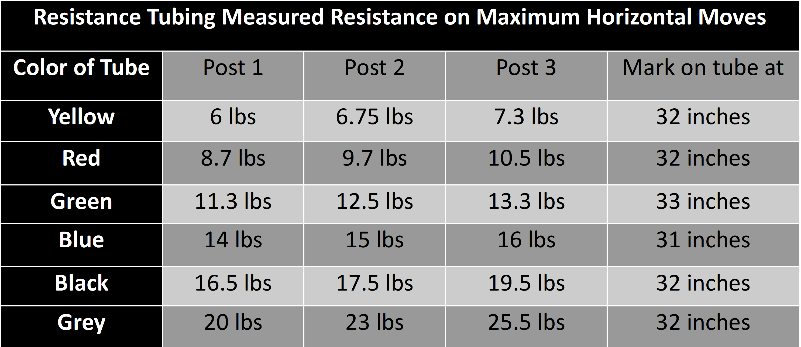

Relieving Tension on the Resistance Bands

Resistance bands only have a suggested use life of 6 months. While we offer replacement bands on our website, we advise relieving tension on the resistance bands when the XFlex is not in use. Follow the following steps to relieve the tension on the resistance bands.
- Unplug the resistance bands from the resistance ports. 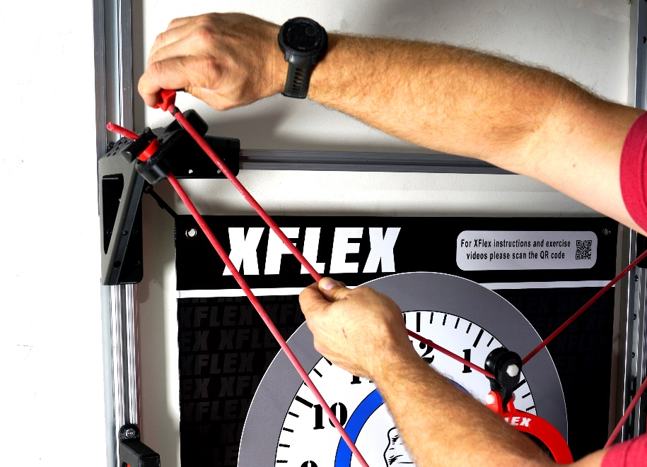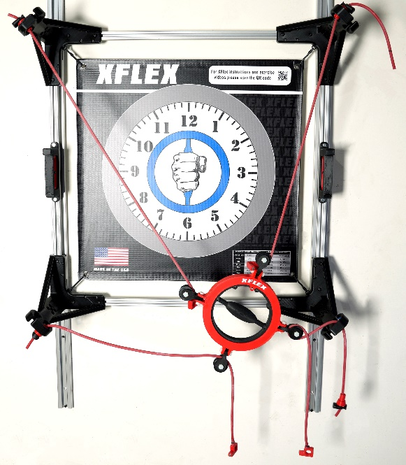
- Hang the central handle on the handle hook.
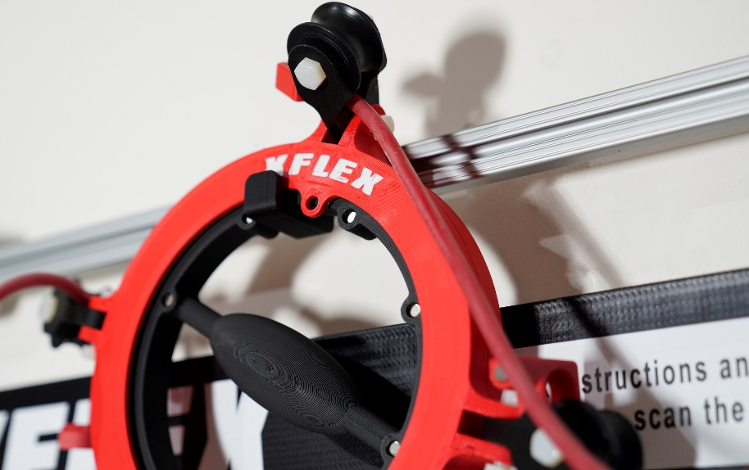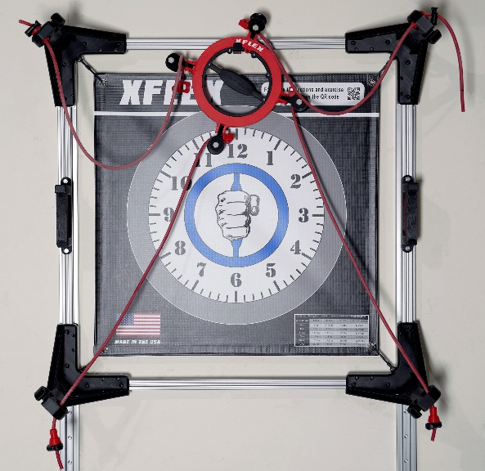
Congrats! The tension is now relieved.

We at ST Sports hope that your XFlex helps you in your upper body strengthening journey. If you have any questions, please contact us at support@h2xflex.com or call our customer support at 815-370-8034.

